|  |  |
| --- | --- |
|  | **FPT ACADEMY INTERNATIONAL**  **FPT – APTECH COMPUTER EDUCATION** |

**Centre Name: ACE-THUDUC-1-FPT**

**Address: 391A Nam Ky Khoi Nghia, District 3, Ho Chi Minh City, Viet Nam.**

FLORAL DECORS

|  |  |  |
| --- | --- | --- |
| **Supervisor.** | Mr. Nguyen Phat Tai | |
| **Batch.** | T3.2307.E1 | |
| **Group.** | Group 1 | |
| **Serial No.** | **Enrollment Number** | **Student Name** |
| 1. | Student1491654 | Tran Ngoc Son |
| 2. | Student1491735 | Luu My Le |
| 3. | Student1491481 | Nguyen Van Quy |
| 4. | Student1455759 | Vo Xuan Thinh |

Nov-14-2023

**This is to certify that**

**Mr/Ms:**

Tran Ngoc Son

Luu My Le

Nguyen Van Quy

Vo Xuan Thinh

**has successfully designed & developed**

eProject: Floral Decors website

**Submitted by: Tran Ngoc Son**

**Date of issue: 14-Nov-2023**

**Authorized Signature: Son**

**TABLE OF CONTENTS**

ACKNOWLEDGEMENT 3

SYNOPSIS 3

PROBLEM DEFINITION 3

CUSTOMER'S REQUIREMENTS SPECIFICATIONS (CRS) 4

Business/Project Objective: 4

Hardware/ Software Requirements: 5

SCOPE OF THE WORK (IN BRIEF) 5

Architecture and design of the system 7

Diagram of the website 8

TASK SHEET REVIEW 1 9

SITE MAP 10

MOCK OF THE WEBSITE 11

**1.** **HOMEPAGE** 11

**2.** **PRODUCTS** **Error! Bookmark not defined.**

**3.** **BRANDS** **Error! Bookmark not defined.**

**4.** **COMPARE** **Error! Bookmark not defined.**

**5.** **CONTACT US** 15

**6.** **ABOUT US** **Error! Bookmark not defined.**

TASK SHEET REVIEW 2 Error! Bookmark not defined.

**WEBSITE DESCRIPTION 18**

**1. HOME PAGE: 18**

**2. MENUDROPDOWN01:** Error! Bookmark not defined.

**3. MENUDROPDOWN02** Error! Bookmark not defined.

**4. PRODUCT PAGE:** Error! Bookmark not defined.

**5. BRANDS PAGE** Error! Bookmark not defined.

**6. PRODUCT DETAIL:** Error! Bookmark not defined.

**7. ABOUT US PAGE: 30**

**8. CONTACT PAGE: 31**

**TASK SHEET REVIEW 3 32**

# ACKNOWLEDGEMENT

On behalf of all members of Team 1, I would like to thank you all for your hard work and efforts to successfully complete this eProject.

Thank you, Mr. Nguyen Phat Tai, for your enthusiastic and dedicated guidance, helping us complete this eProject.  
In addition, I would like to thank all Team 1 members, each member has worked hard to complete the assigned work for this project.

Not only this eProject, we will put more effort into future projects as well as future work.

# SYNOPSIS

“Blooming Petals” is selling various types of flowers and floral decorations. The company advertises by distributing the pamphlets, advertising on television and so on. Due to rapid development in internet field, the company decides to launch a website where people will get all the information about the various products available with them easily.

# PROBLEM DEFINITION

The Web site is to be created based on the following requirements.  
 1) The Home Page should be created with sections, graphics and with a suitable logo.

2) Home Page should contain details of different flowers/floral decors with suitable images.

3) The site should display a menu which will contain the options for brief introduction about the various floral themes/decorations available, location of the shop and any other information if required.

4) The information about products should be presented in two ways:

(a) Information should be available category wise, wherein user can click on a particular category and should be able to view all the products related to the category available with complete information. Eg. Category can be “Birthdays”, “Anniversaries”, marriages” etc. with suitable sub-categories been defined.

(b) Information should be categorized according to the type of flowers like if a User wants to see only “Rose decors” or any other particular flower products then he/she can click on a Link/button/menu etc and can see only that products.

5) When a user selects any particular flower, a list of products for that brand will be displayed

6) A brief summary of individual products should be displayed on the Web Page along with the product but detailed Features should be stored in Individual Word documents which can be downloaded or viewed by the User who wishes to see the same.

7) The user should also be able to compare the various products of different as well as similar categories.

8) There should be a “Contact Us” page which will have the Address of the Company with location should be displayed using GeoLocation API (eg.GoogleMaps) and the mail address which when clicked will invoke the local mail client from where they can send an email.

# CUSTOMER'S REQUIREMENTS SPECIFICATIONS (CRS)

**Client: Floral Decors**

### Business/Project Objective:

The Objective of this program is to give a sample project to work on real life projects. These applications help you build a larger more robust application.

The objective is not to teach you JavaScript/Dreamweaver but to provide you with a

real life scenario and help you create basic applications using the tools.

You can revise the chapters before you start with the project.

This project is meant for students who have completed the module of HTML5. These

programs should be done in the Lab sessions with assistance of the faculty if required.

It is very essential that a student has a clear understanding of the subject. Students

should go through the project and solve the assignments as per requirements given.

Kindly get back to eProjects Team in case of any doubts regarding the application or

its objectives.

**Input to the system:**

* Browsing products based on brands, type of appliances..

**Output from the system:**

* A menu that will categorize all the functions of the site.
* Display the list of available albums category wisely.
* Perform the brief comparison by showing 2 products of the same type with their details.
* Site should be able to provide brief introduction/history about the company under About Us page.
* The location of the company is in Contact Us page.
* Besides the above requirements, the site should have look and feel as per the industry standards.

**Expected delivery date:** 14-Nov-2023.

**List of deliverables:**

* + - * Document Word.
      * User Guide.
      * Source code.

### Hardware/ Software Requirements:

**Hardware**

* + A minimum computer system that will help you access all the tools in the courses is a Pentium 166 or better.
  + 64 Megabytes of RAM or better.

**Software**

* + Notepad/HTML editor/CoffeeCup
  + Angular / Angular JS / React / BootStrap
  + Dreamweaver / Figma
  + MS IE / Chrome / FireFox / Netscape /MS Edge

# 

# 

# 

# SCOPE OF THE WORK (IN BRIEF)

**The team has discussed and has agreed about the website layout as shown briefly below:**

1. **Homepage**: Showing brief introduction about the company and type of products that it is selling.
2. **Products**: Containing its products with their details and images categorized by type.
3. **Brands**: Containing its products with their details and images categorized by brands of the products.
4. **Compare**: Providing a clear view to the customer for brief comparison of 2 products among those on sale.
5. **Contact Us**: Showing the contact information of the company such as address, location map, mobile, fax, email.
6. **About Us**: Introducing the history, achievements and further information about the company.
7. **Category**: Users click on a particular category and should be able to view all the products related to the category available with complete information.

# 

# Architecture and design of the system

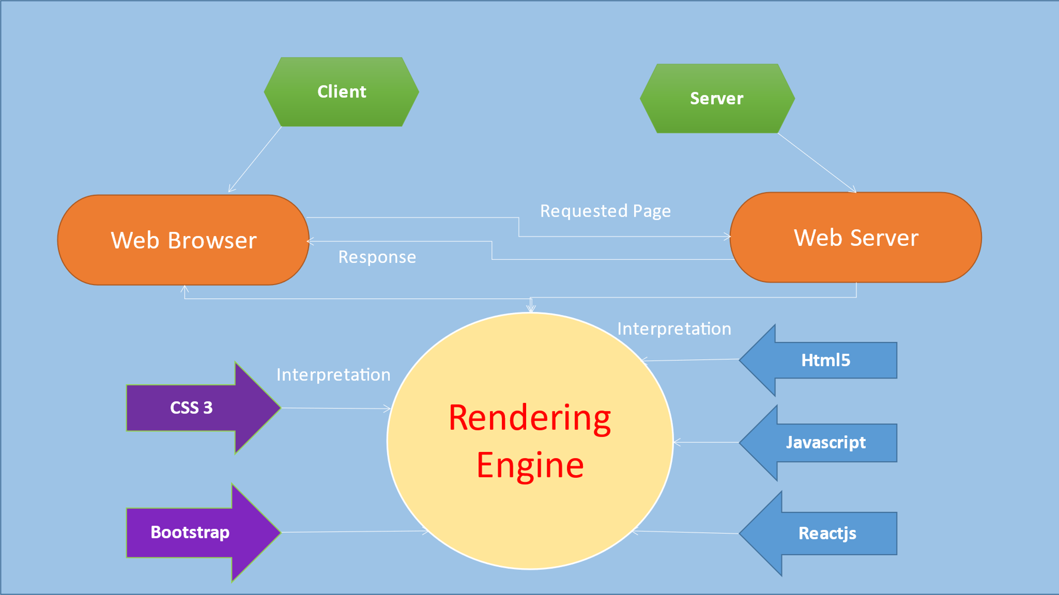

# Diagram of the website

**­­** 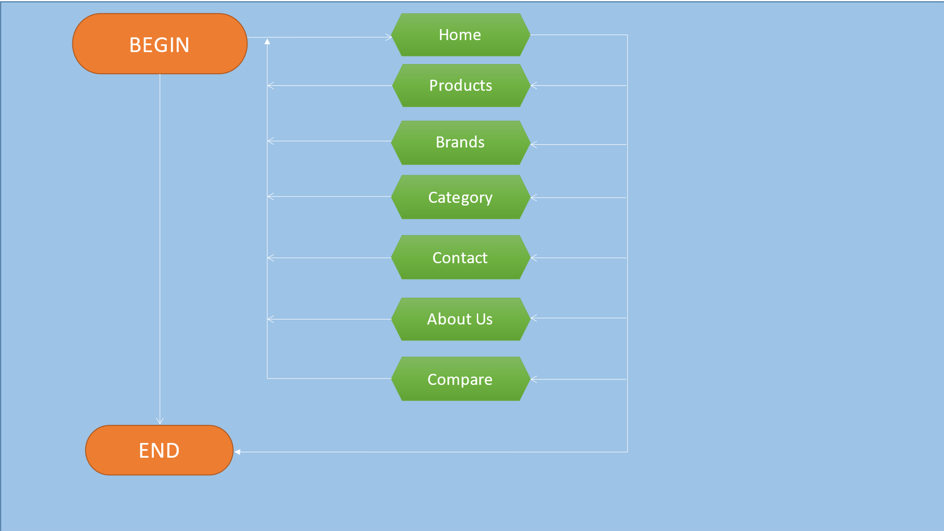



TASK SHEET REVIEW 1

|  |  |  |  |  |  |  |  |
| --- | --- | --- | --- | --- | --- | --- | --- |
| **Project Ref. No.:**  **eP/Advertisement Portal Management**  **System/01** | | **Project  Title:** | **Activity Plan Prepared By:** | **Date of Preparation of Activity Plan:** | | | |
| **Sr.**  **No.** | **Task** | **Actual**  **Start Date** | **Actual Days** | **Team**  **Mate Names** | **Status** |
| 1 | Problem Statement | Floral Decors | Son | 19-Oct-2023 | 1 | Son, Quy, Le, Thinh | Completed |
| 2 | Analysis of the requirements about the website | 19-Oct-2023 | 1 | Son, Quy, Le, Thinh | Completed |
| 3 | The scope of the work  (in brief) | 19-Oct-2023 | 1 | Son, Quy, Le, Thinh | Completed |
| 4 | Architecture and design of the system | 19-Oct-2023 | 1 | Son, Quy, Le, Thinh | Completed |
| 5 | Diagram of the website | 19-Oct-2023 | 1 | Son, Quy, Le, Thinh | Completed |
| 6 | Task Sheet | 19-Oct-2023 | 1 | Son, Quy, Le. Thinh | Completed |

|  |  |
| --- | --- |
| **Date: 20/10/2023** | |
| Signature of Instructor:  **Mr. Nguyen Phat Tai** | Signature of Team Leader:    **Mr.Tran Ngoc Son** |

# SITE MAP

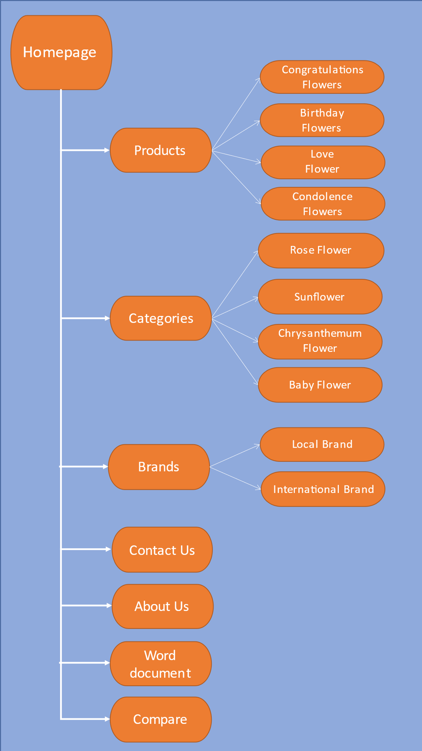

# MOCK OF THE WEBSITE

1. **HOMEPAGE**

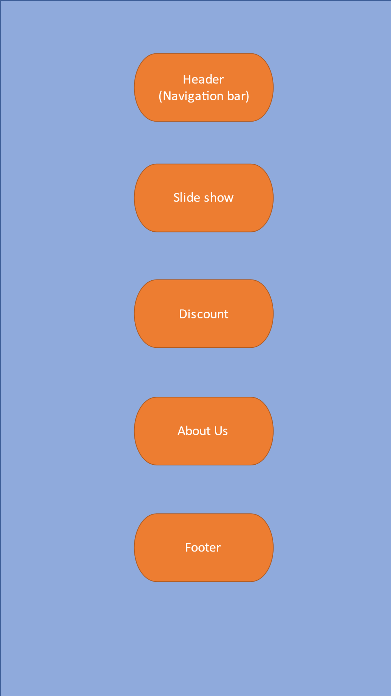

# PRODUCT

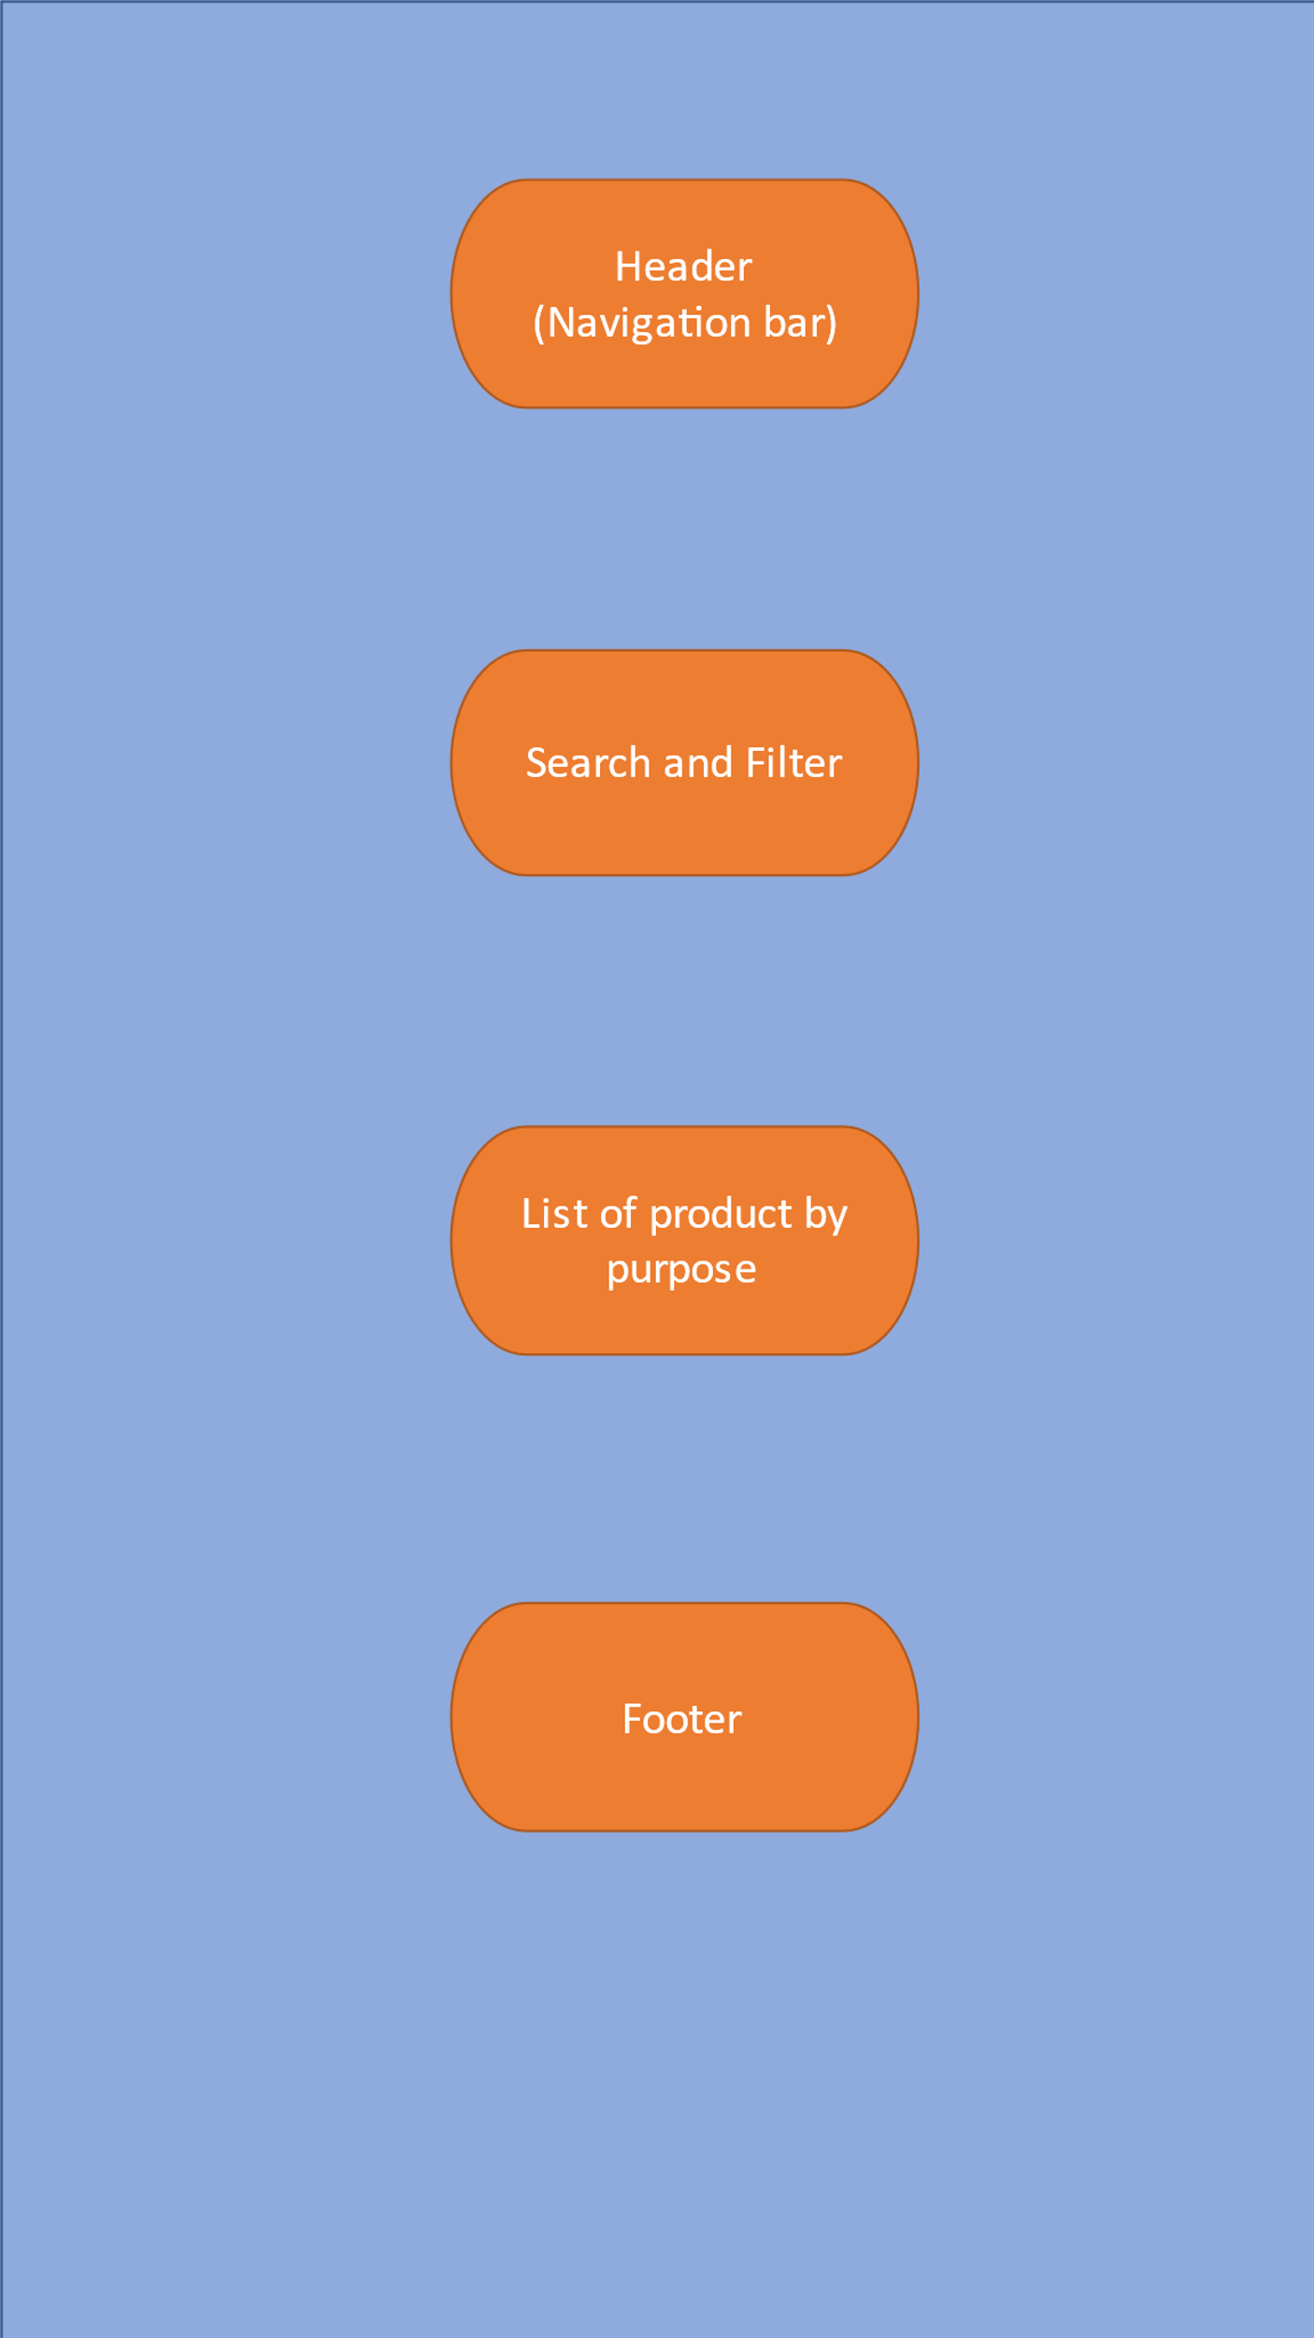

**3. BRAND**

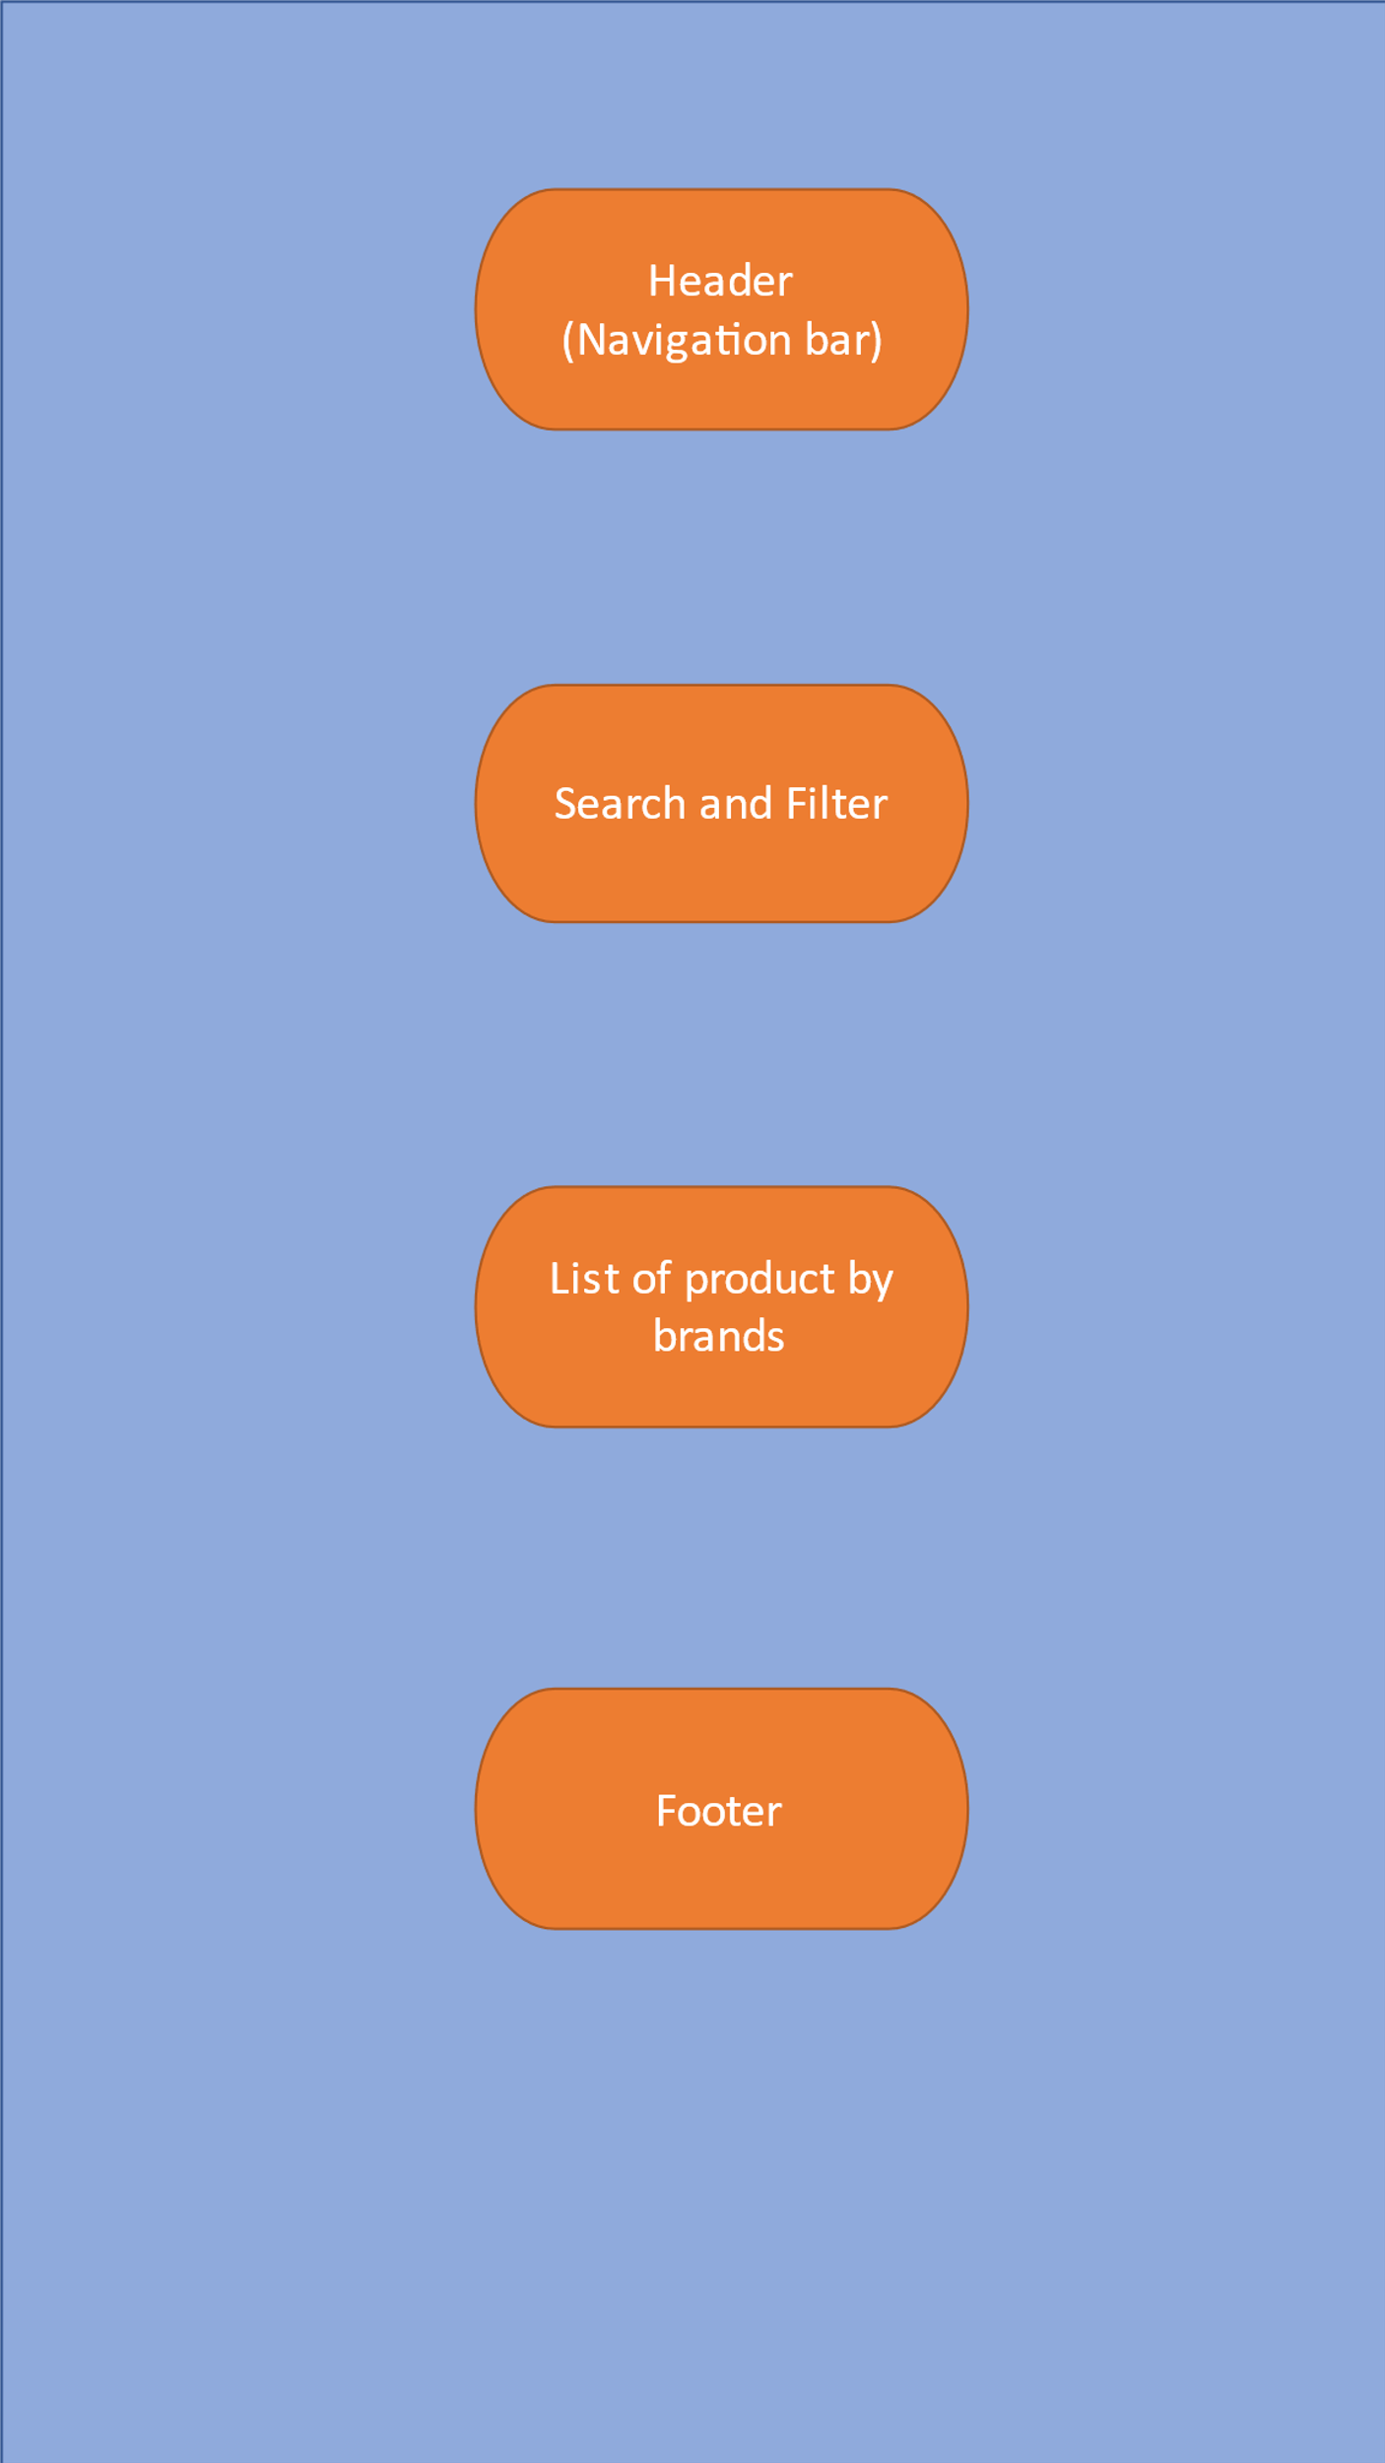

**4.SERVICER**

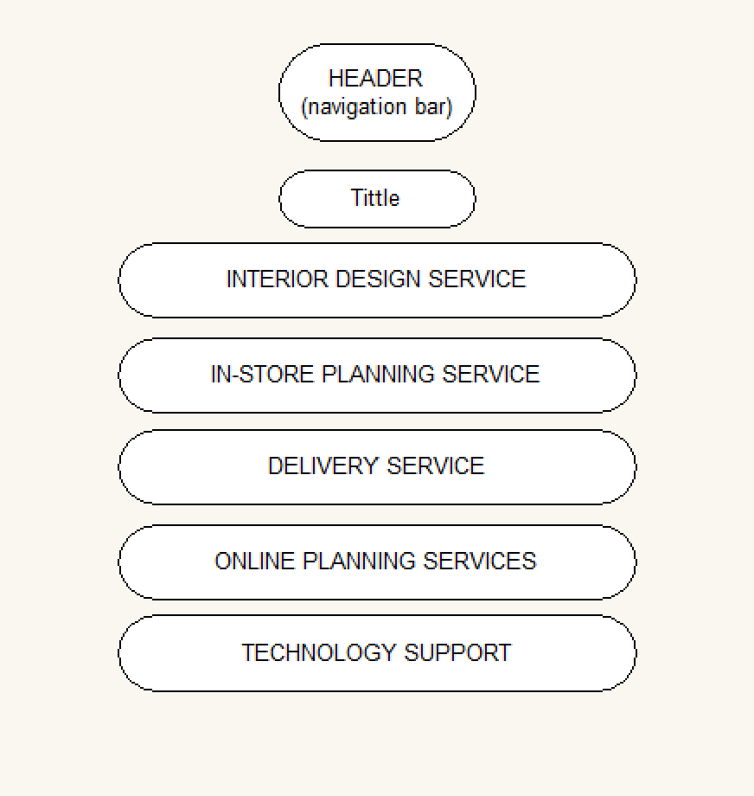

**5. COMPARE**

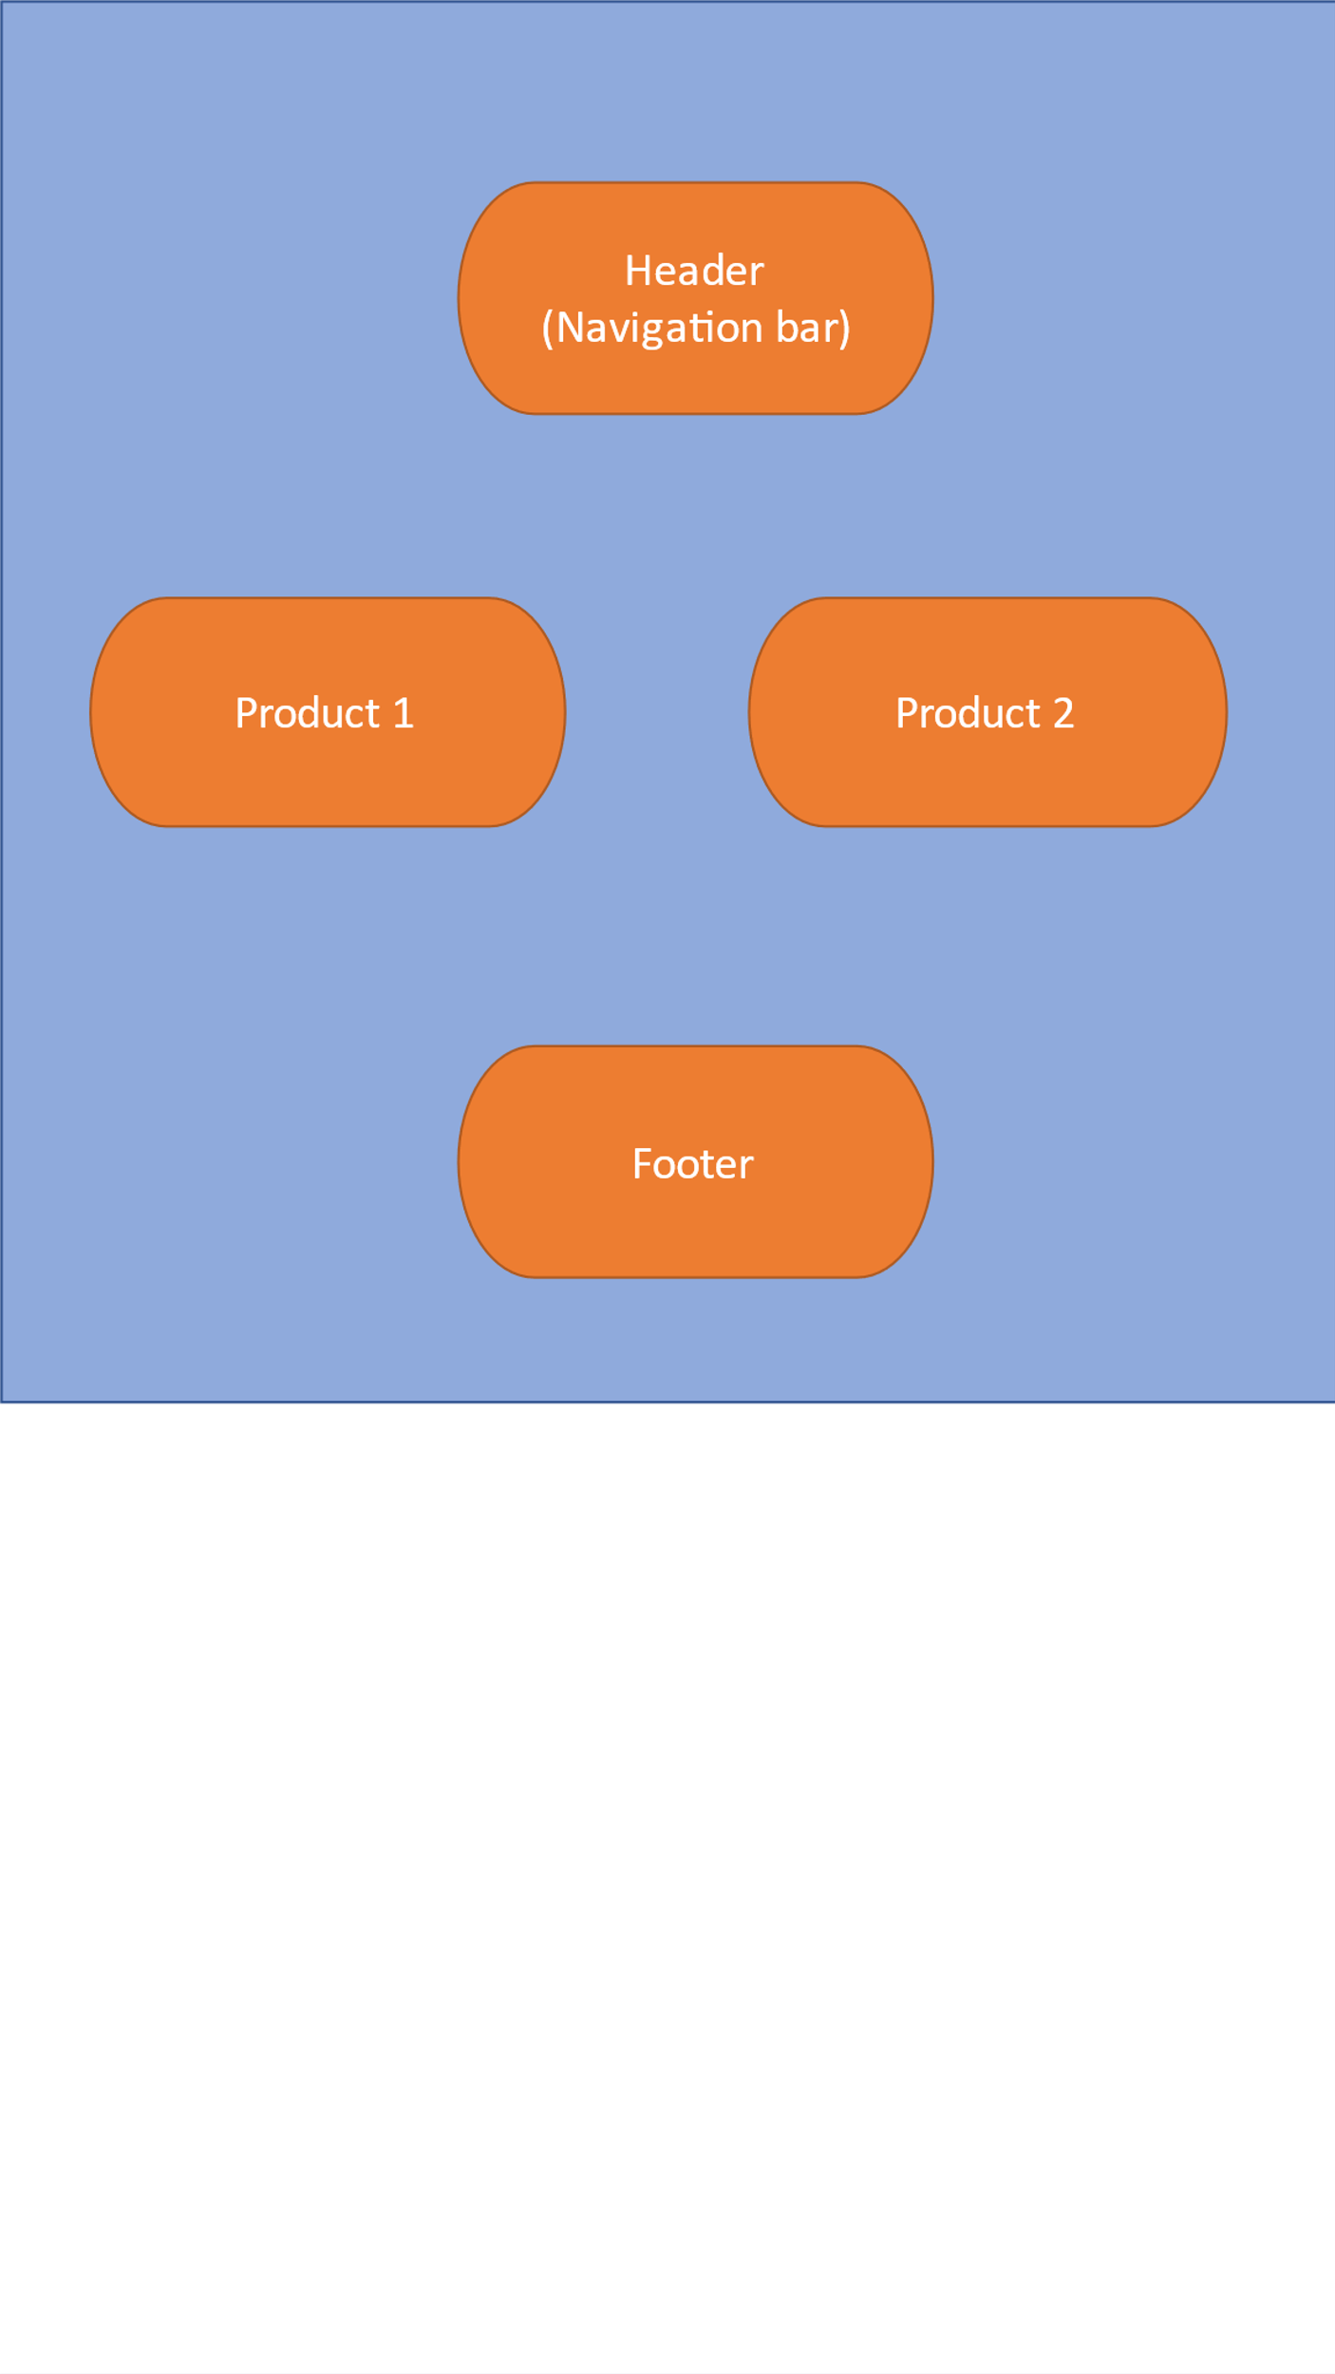

**6. CONTACT US**

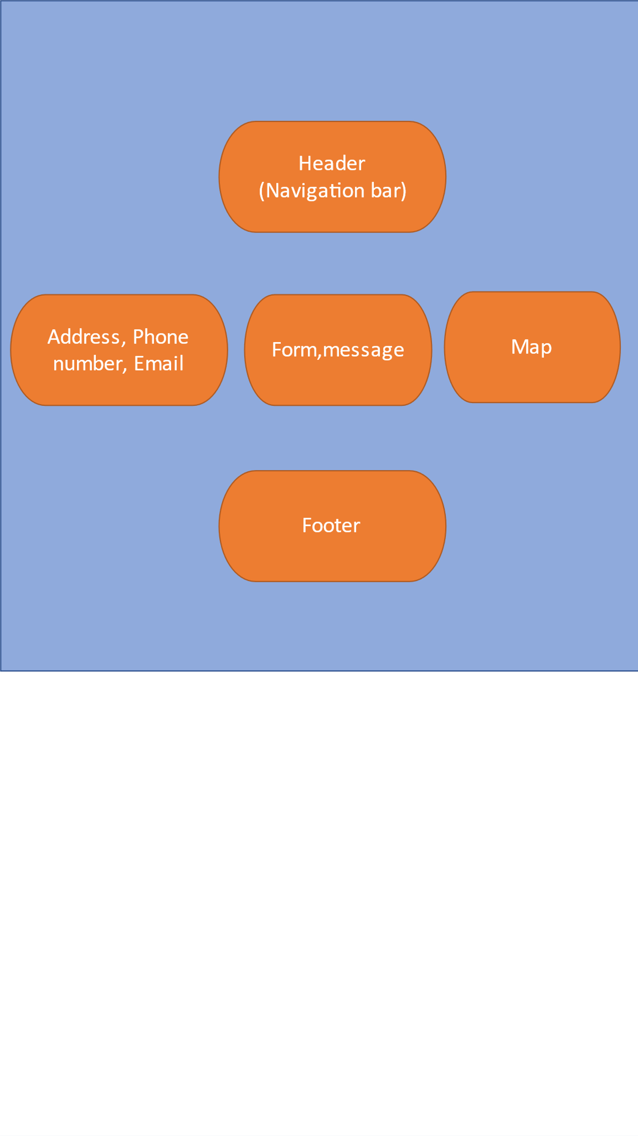

**7. ABOUT US**

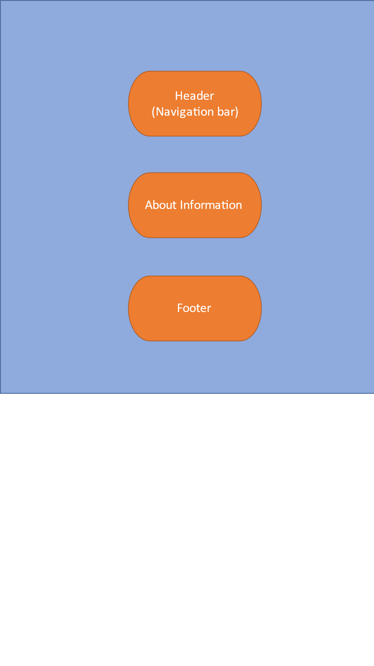

# TASK SHEET REVIEW 2

|  |  |  |  |  |  |  |  |
| --- | --- | --- | --- | --- | --- | --- | --- |
| **Project Ref. No.:**  **eP/Advertisement**  **Portal Management System/01** | | **Project Title:** | **Activity Plan Prepared By:** | **Date of Preparation of Activity Plan:** | | | |
| **Sr.**  **No.** | **Task** | **Actual**  **Start Date** | **Actual Days** | **Team**  **Mate Names** | **Status** |
| 1 | Site map | Floral Decors | Son | 26-Oct-2023 | 1 | Son, Quy, Le, Thinh | Completed |
| 2 | Mock of the website | 26-Oct-2023 | 1 | Son, Quy, Le, Thinh | Completed |
| 3 | Task Sheet | 26-Oct-2023 | 1 | Son, Quy, Le, Thinh | Completed |

|  |  |
| --- | --- |
| **Date: 26/Oct/2023** | |
| Signature of Instructor:  **Mr. Nguyen Phat Tai** | Signature of Team Leader:  **Mr.Tran Ngoc Son** |

# WEBSITE DESCRIPTION

1. **HOME PAGE:**

* Screenshot

# 

**Figure 1.1:** Homepage slideshow

**Figure 1.2:** Footer

1. **MenuDropdown01**

**3.MenuDropdown02**

**4.Products Page**

**5.Brands Page**

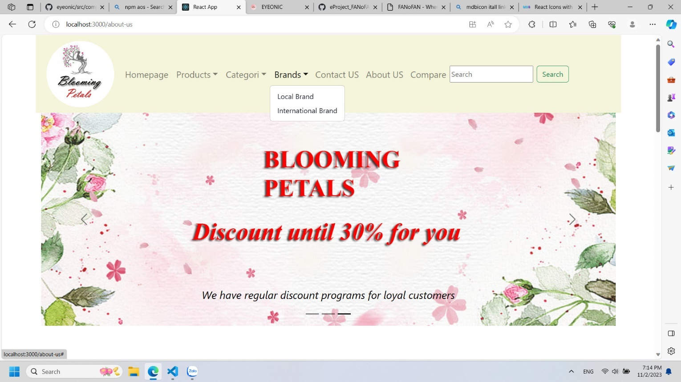

**6.Product Detail**

**7.About Us Page**

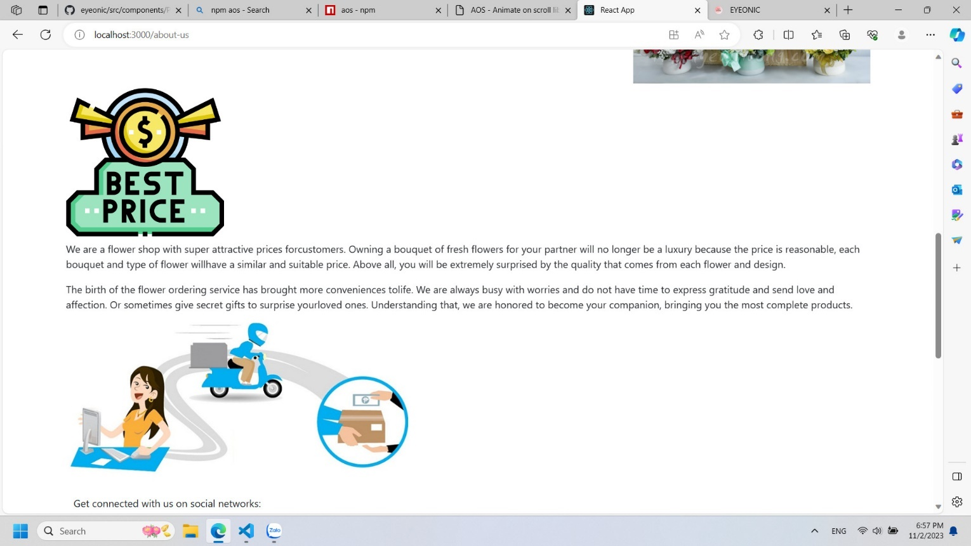

**8.Contact Page**

**9.Compare Page  
  
**

**SOURCE CODE**

**HomePage**

**SlideShow**

**Brands**

**Product Json 1**

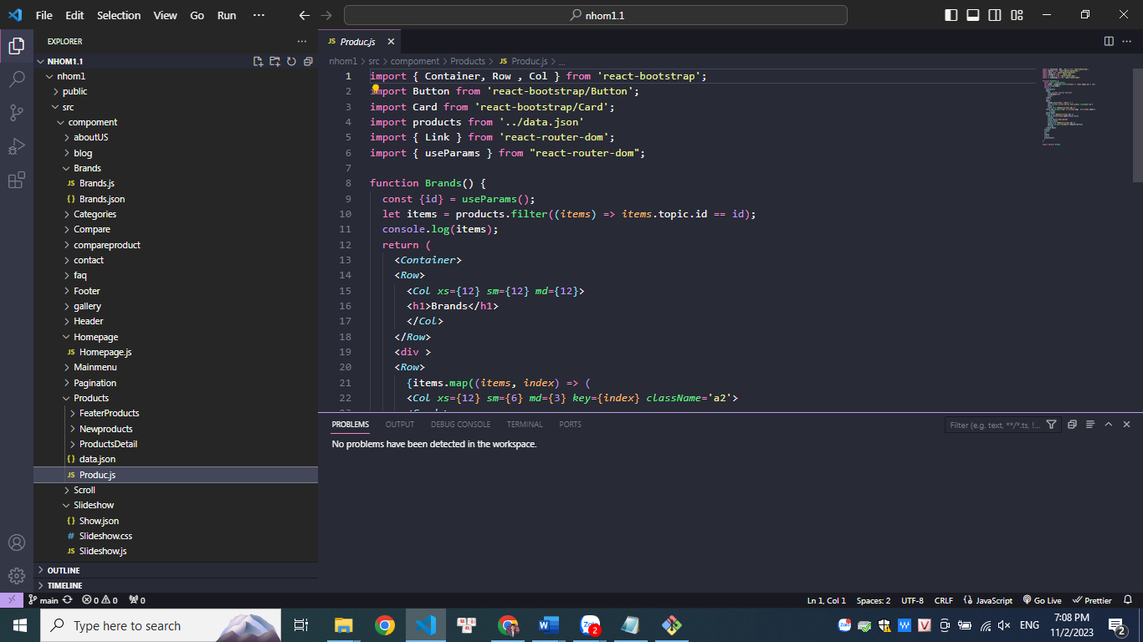

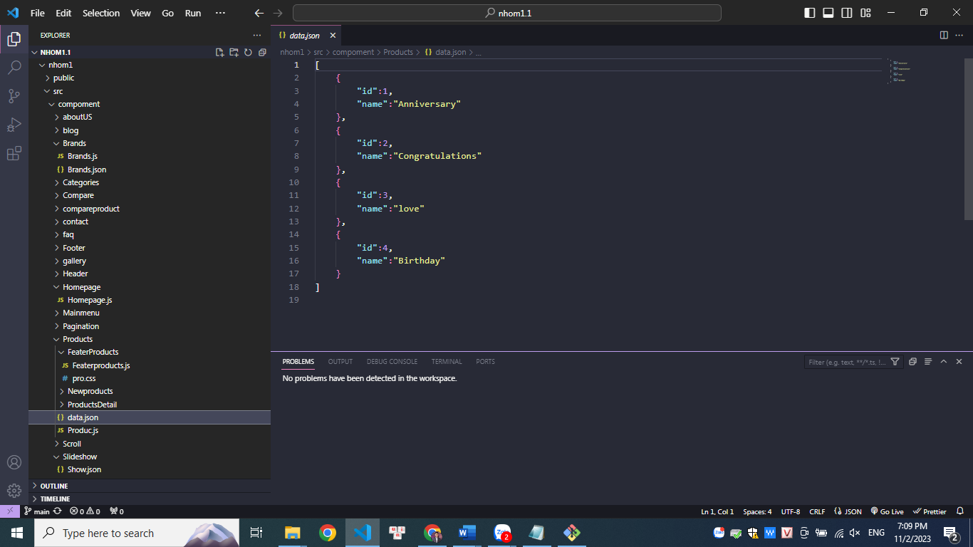

**Product Json 2**

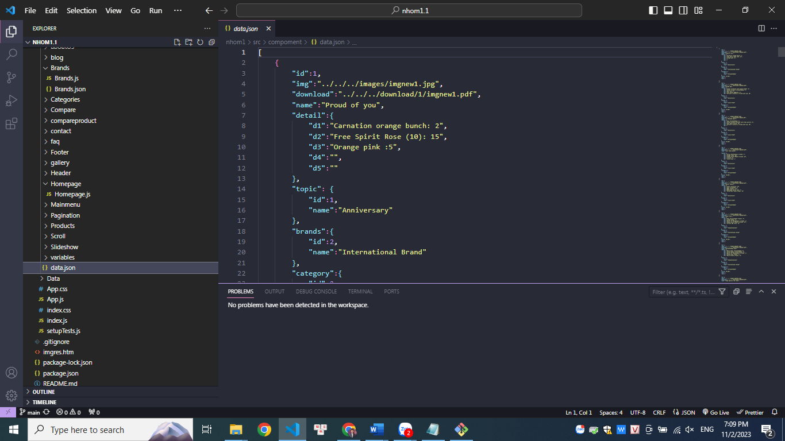

**About Us**

**Contact us**

**Compare**

# TASK SHEET REVIEW 3

|  |  |  |  |  |  |  |  |
| --- | --- | --- | --- | --- | --- | --- | --- |
| **Project Ref. No.:**  **eP/Advertisement**  **Portal Management System/01** | | **Project Title:** | **Activity Plan Prepared By:** | **Date of Preparation of Activity Plan:** | | | |
| **Sr.**  **No.** | **Task** | **Actual**  **Start Date** | **Actual Days** | **Team**  **Mate Names** | **Status** |
| 1 | Home page | Floral Decors | Son | 02-Nov-2023 | 1 | Son, Quy, Thinh | Completed |
| 2 | MenuDropdown01 | 02-Nov-2023 | 1 | Son, Quy, Thinh | Completed |
| 3 | MenuDropdown02 | 02-Nov-2023 | 1 | Son, Quy, Thinh | Completed |
| 4 | Brands Page | 02-Nov-2023 | 1 | Son, Quy, Thinh | Completed |
| 5 | Slide show | 02-Nov-2023 | 1 | Son, Quy, Thinh | Completed |
| 6 | Products Page | 02-Nov-2023 | 1 | Son, Quy, Thinh | Completed |
| 7 | Product Detail | 02-Nov-2023 | 1 | Son, Quy, Thinh | Completed |
| 8 | About Us Page | 02-Nov-2023 | 1 | Son, Quy, Thinh | Completed |
| 9 | Contact Page | 02-Nov-2023 | 1 | Son, Quy, Thinh | Completed |
| 10 | Compare | 02-Nov-2023 | 1 | Son, Quy, Thinh | Completed |

|  |  |
| --- | --- |
| **Date: 03/Nov/2023** | |
| Signature of Instructor:  **Mr. Nguyen Phat Tai** | Signature of Team Leader:  **Mr. Tran Ngoc Son** |